PL/SQL 1- LAB 1
1. Write PL/SQL blocks to show the declaration of variables. Follow the following instructions:
- Declare variables for all attributes existing in emp table.
- Variables datatypes should be defined appropriately and use rowtype for any two variables.
- Initialize any two variables at time of declaration.
- Assign values to remaining variables by showing the complete emp table’s attribute data.
2. Write a PL/SQL block to calculate the incentive of an employee whose ID is 110.
3. Write a PL/SQL program to check whether a number is even or odd by using IF END.
4. Write a PL/SQL program to check whether a given number is positive, negative or zero IF ELSE END IF.
5. Write a PL/SQL program to count the number of employees in department 50 and check whether this department has any vacancies or not. There are 45 vacancies in this department.
6. Write a PL/SQL program to make a calculator (DMAS rules) using CASE statement.
7. Write a program in PL/SQL to print factorial of given number. (using for loop)
8. Write a program in PL/SQL to update the salary of a specific employee by 8% if the salary
exceeds the mid-range of the salary against this job and update up to mid-range if the salary is less than the mid-range of the salary, and display a suitable message.
9. Correct the program and find the output:
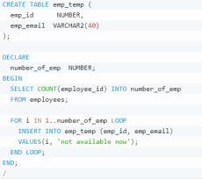s

